

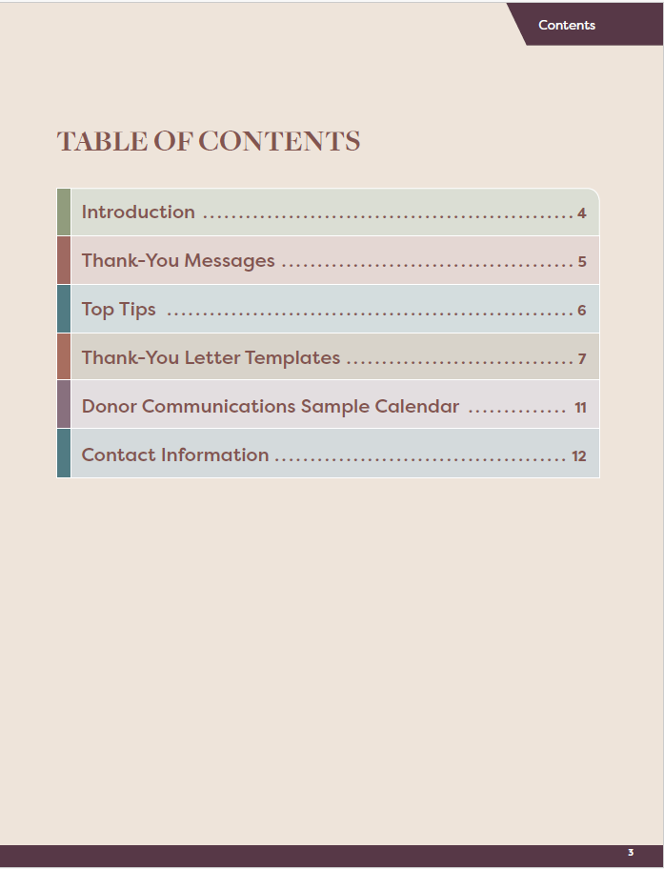

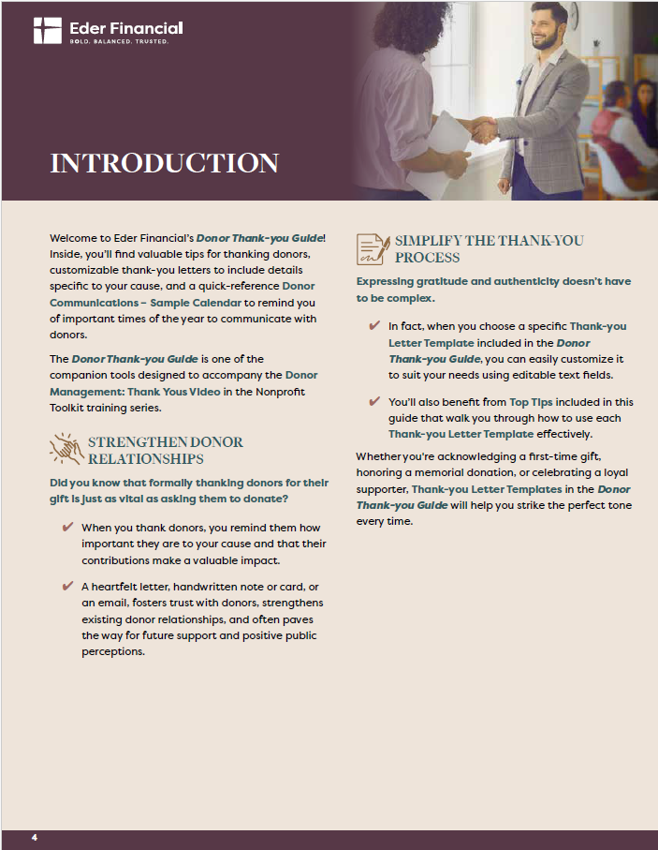

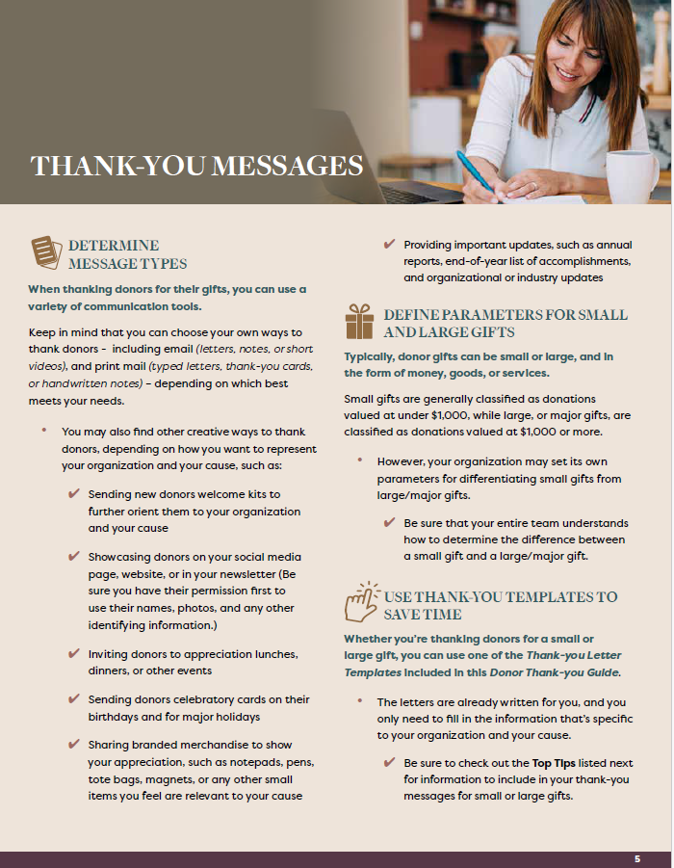



**Small Gift - Thank-you Letter Template**

***Example:*** Gift value of less than $1,000

**For Email Subject Line or Subject of Typed Letter or Note:**

*Thank You for Your Generous Support!*

**For Emails, Typed Letters or Notes:**

[Insert your organization’s letterhead, or type your organization’s name and address here.]

[Insert current date]

Dear [Donor's Name – First Name or Mr./Mrs./Ms. + Last Name],

I hope this message finds you well. On behalf of [Add your organization's name here and/or names of important stakeholders, such as board or staff members], we’d like to thank you for your generous gift of [$XXX.00].

You are supporting [Add a brief description of your organization’s mission and/or program impact]. Your gift is a blessing that will help us continue our mission to [Include a summary of your organization’s core purpose or impact].

Your generosity will help us carry out this year’s special projects [Insert specific use of funds or project supported]. We are deeply grateful for your commitment to [Express gratitude for the donor’s commitment to your mission or organization].

We look forward to keeping you regularly updated on our progress and the positive changes your donation will help to create.

Thank you once again for your kindness and support.

With warm regards,

[Name]

[Title]

[Nonprofit Organization's Name]

[Contact Details – Email, Phone]

[For emails and typed letters, **add the URL here of your organization’s website Home page or the page on your website** that pertains to the cause or project that the donor supported.]

**Large/Major Gift - Thank-you Letter Template**

***Example:*** Gift value of less than $1,000

**For Email Subject Line or Subject of Typed Letter or Note:**

*Heartfelt Thanks for Your Exceptional Support!*

**For Emails, Typed Letters or Notes:**

[Insert your organization’s letterhead, or type your organization’s name and address here.]

[Insert current date]

Dear [Donor's Name – First Name or Mr./Mrs./Ms. + Last Name],

I hope this message finds you and your family well. I am writing on behalf of [Add your organization's name here and/or names of important stakeholders, such as board or staff members] to express our deepest gratitude for your incredibly generous donation of [$XXXX.00].

You are supporting [Add a brief description of your organization’s mission and/or program impact]. Your gift is a blessing that will help us continue our mission to [Include a brief summary of your organization’s core purpose or impact].

Specifically, your generous gift will significantly help us complete [Describe the current project(s) or initiative(s) that the donation supports]. We are deeply grateful for your commitment to [Insert your organization’s name], and we could not exist without donors like you.

We will send you regular updates on our progress and the positive changes that your donation will help to create.

Please enjoy the enclosed photo and inspirational message from [Insert a brief description of the image/message that you’re including].   
  
Thank you, once again, for your kindness and support.

With warm regards,

[Name]

[Title]

[Nonprofit Organization's Name]

[Contact Details – Email, Phone]

[For emails and typed letters, **add the URL here of your organization’s website Home page or the page on your website** that pertains to the cause or project that the donor supported.]

**Additional Customizations to Thank-you Letter Templates**  
Below are optional paragraphs you can use to personalize the second or third paragraphs   
in the ***Thank-you Letter Templates***, or anywhere in the letter you determine works best,   
based on the donor’s relationship with you, or on their giving patterns.

Simply insert one of the messages listed below into one of the templates that best fits   
the tone and format of your communication.

**First-time Donor**

*[As a first-time donor, your support is especially meaningful to us — we’re honored   
by your trust and excited to have you in our community.]*

**Frequent/Ongoing Donor**

*[This gift is one of the many you have given to [organization name]. It represents a pattern   
of matchless generosity that is vital to our ongoing success and will carry us into the future.   
We are able to flourish because of your unfailing support.]*

**Ongoing Donor**

*[We are proud to count you among those who have given us repeated support.   
We could not exist without your kind of ongoing generosity.]*

**Remembrance Gift Donor**

*[Thank you for your generous gift made in memory of [insert name of person honored].   
We are honored to be part of a tribute that carries their legacy forward.]*



